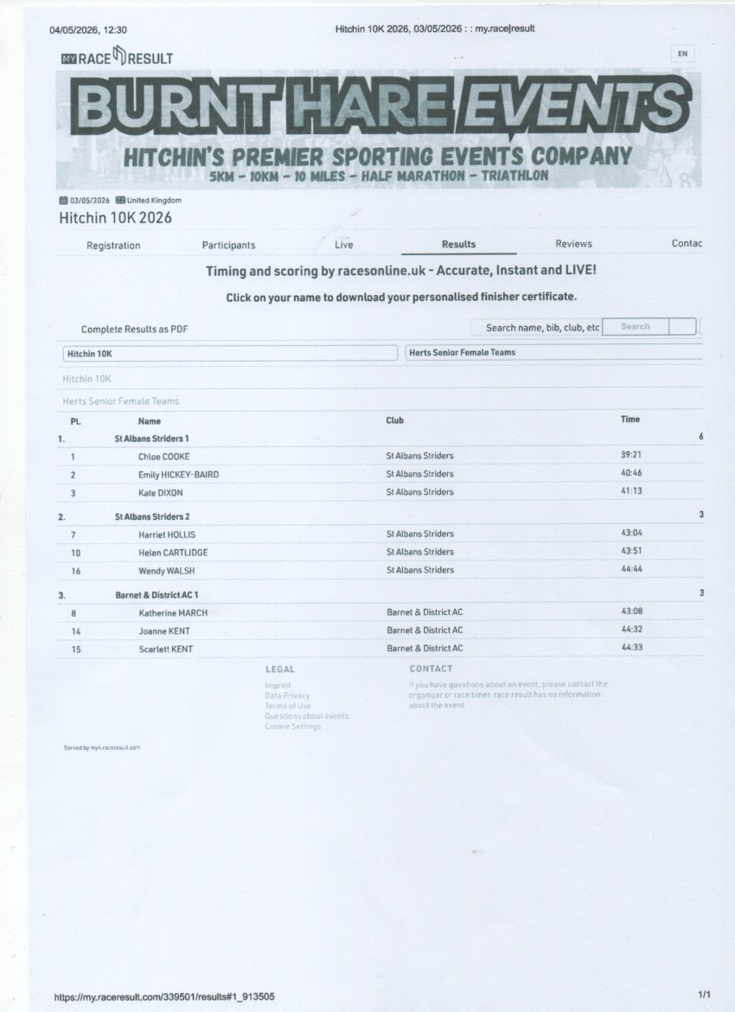
https://my.raceresult.com/339501/#1_C2E637

