Hertfordshire U13 Athletes Awarded County Vests
Monday 16th July saw twenty-seven U13 athletes from across the Hertfordshire receive their County Vests from Commonwealth Games Athlete Maria Vedeille at Jarman Park, Hemel Hempstead.

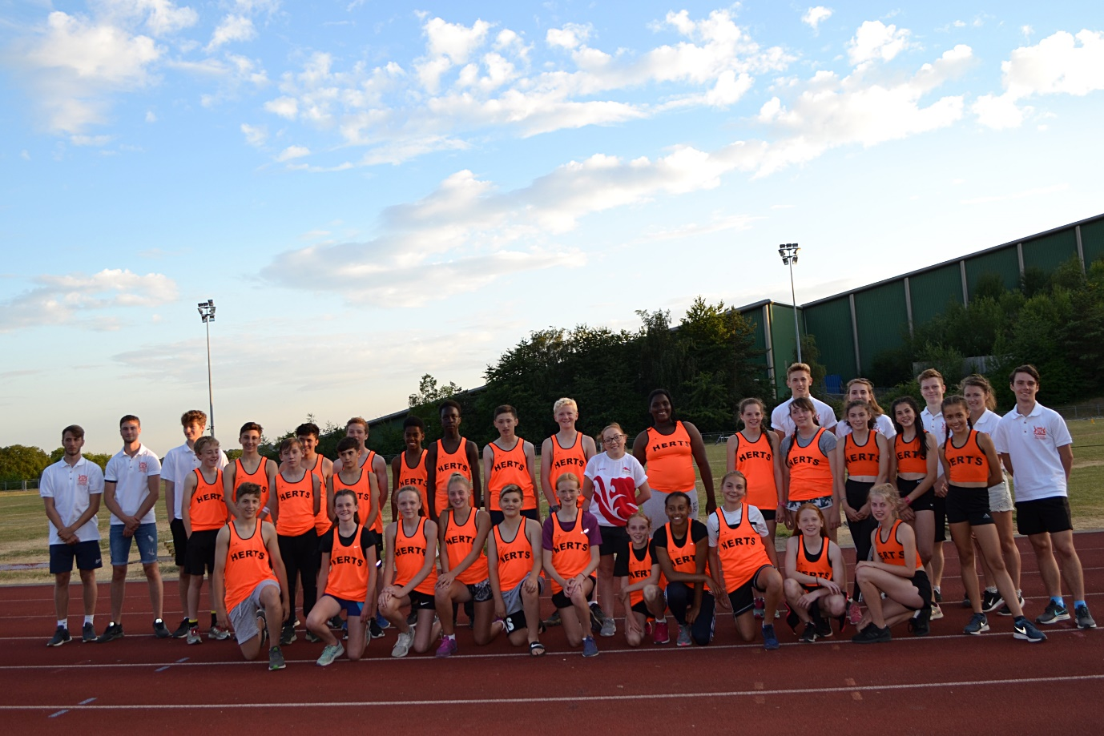

Selected to represent Hertfordshire at the U13 Inter County March at the Kingsmeadow Stadium, Kingston upon Thames later in July the youngsters came together to meet their team managers, each other and receive their County Vests. The event was organised and run by the Hertfordshire Young Leaders Academy. Warm up and ‘ice breaker’ games and exercises were run by the Leaders who also talked to parents and athletes about their experiences representing Hertfordshire. Maria Verdeille presented the youngsters with their County vests at the end of the evening.
Maria made her Commonwealth Games debut on the Gold Coast competing at the Carrara Stadium in the T35 100m event. Recording a time of 19.38 -her best time in the last 5 years.

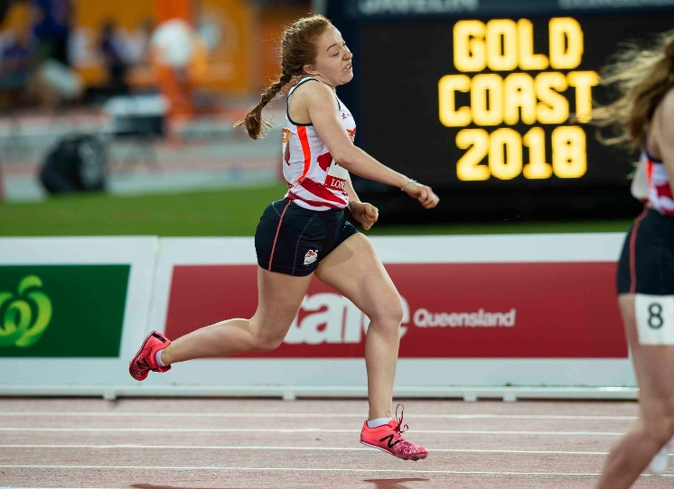

Photo Gary Mitchell

